LAB 8

Group 14

Khoo Jie Xuan

Putera Syabil

Pharveish Ail Selvam

EXERCISE 1

QUESTION 1

A) 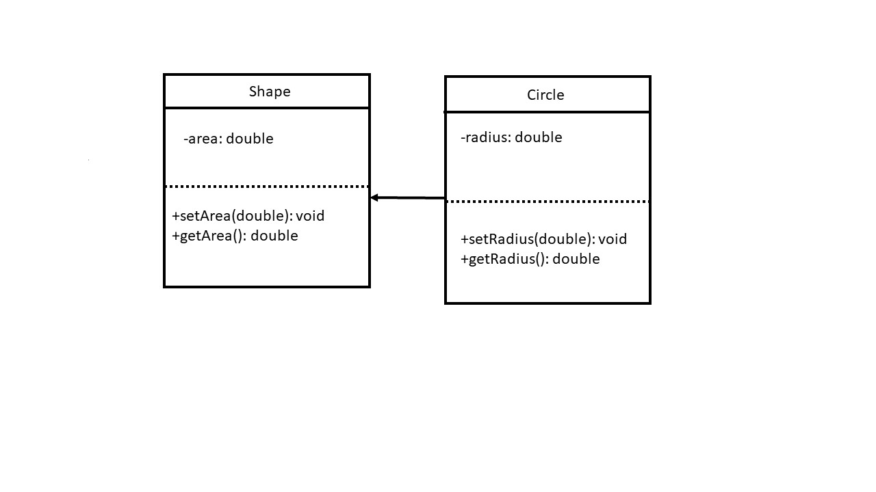

B) Public members of Circle : setRadius(double), getRadius(), setArea(double), getArea()

C) Private member of Shape, area.

D)

|  |  |
| --- | --- |
| c.setRadius(10.0) | Legal |
| s.setRadius(10.0) | Illegal |
| cout<<c.getArea() | Legal |
| cout<<s.getArea() | Legal |

QUESTION 2

A) this -> width = width;

this -> length = length;

B) : public Rectangle

C) Square(double, double, double)

D) Square(double width, double length, double height)

:Rectangle(width, length)

E) calculateArea()*height

F) cout<<Rectangle::display()

G) Square squareBox(15,10,10)

H) double volume = squareBox.calculateVolume();

I) squareBox.display();

QUESTION 3

|  |  |
| --- | --- |
| Member Variable | Access Specification in Words Class |
| name | Inaccessible |
| page | Protected |
| publisher | Protected |
| numWords | Inaccessible |
| meaning | Protected |
| words | Public |
| perkataan | Protected |
| num | Private |
| source | Public |

QUESTION 4

A)

i)

Automobile object: BMW makes in 2010. The price is RM 150000.00.

Car with car’s make, year model and price (“BMW”, 2010, 150000.0) accordingly.

II)

Automobile object: Toyota makes in 2014. The price is RM 45000.00.

Toyota’s car has 4 doors.

This is the truck with 4WD drive type.

iii)

An automobile object has been created but not yet have details.

B)

|  |  |  |  |  |  |
| --- | --- | --- | --- | --- | --- |
| Object | Make | Model | Price | Doors | Drivetype |
| Car | Own | Own | Own | Own | No |
| Truck | Own | Own | Own | Own | Own |
| Automobile | Own | Own | Own | No | No |

C)

|  |  |  |  |  |  |
| --- | --- | --- | --- | --- | --- |
| Object | Make | Model | Price | Doors | Drivetype |
| printInfo() | Accessible | Accessible | Accessible | No | No |
| printCar() | No | Accessible | Accessible | Accessible | No |
| printTruck() | No | Accessible | Accessible | No | Accessible |
| automobile | No | No | Accessible | No | No |

QUESTION 5

